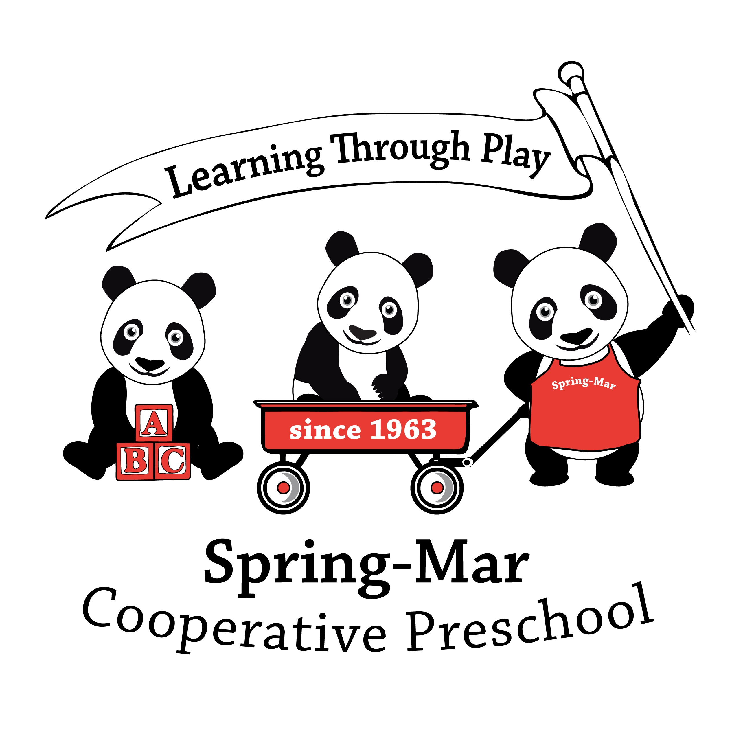
2017-2018 Registration Application

Date __________ Preferred Class: _________
(Navigators - 3 and 4-Year-Olds and Inventors - Pre-K MUST be potty-trained)

Reason for Preference: _____________________________________________________________________________________

Child’s Name: ___________________________________________ M or F Birth Date:________________________________ (Last) (First)
Address: __________________________________________________________________________________________________
(Street) (City) (State/Zip)

Parent/Guardian #1: ________________________________ Email Address:___________________________________________
Home Phone: _____________________ Mobile Phone: _____________________ Office Phone: _______________________

Parent/Guardian #2: ___________________________ Email address:____________________________________________
Home Phone: _____________________ Mobile Phone: _____________________ Office Phone: _______________________

Please specify which phone number we should contact first in emergency: ____________________________________________

Name(s) of Other Children in the Family: Birth Date(s):
____________________________________________________ __________________________________
____________________________________________________ __________________________________
____________________________________________________ __________________________________

Has your child attended school prior to Spring-Mar? YES or NO
If so, school attended: ______________________________________________________________________________________
Is your child a returning student or is your family a Spring-Mar alumni family? YES or NO
If so, year last attended Spring-Mar: _____________________
Does your child have a disability, special need, or IEP? YES or NO
If so, please specify: ________________________________________________________________________________________
Do you (or other participating parent) have any disability/infirmity which will limit your ability to safely participate at Spring-Mar? YES or NO
If so, please specify: _________________________________________________________________________________________
How did you hear about Spring-Mar? ________________________________________________________________________

Obligations:
- Parents participate as a Co-oping Parent/Parent Helper in the class on a rotating basis, arriving earlier and staying late to support teacher and class.
- Co-oping Parents must complete four (4) hours of Parent Education training over the course of the year according to state licensing requirements.
- Each family performs a minimum of 12 hours of additional service to the school per semester as detailed in parent handbook.
- Fulfill all other obligations as outlined in Parent Handbook.

Signature: ____________________________________________

Please sign and return this application with your non-refundable $90 fee ($70 for returning members) to:

Spring-Mar Cooperative Preschool
10125 Lakehaven Court
Burke, VA 22015

Office use only

Check # __________ Date _____________ Amt. _____________

