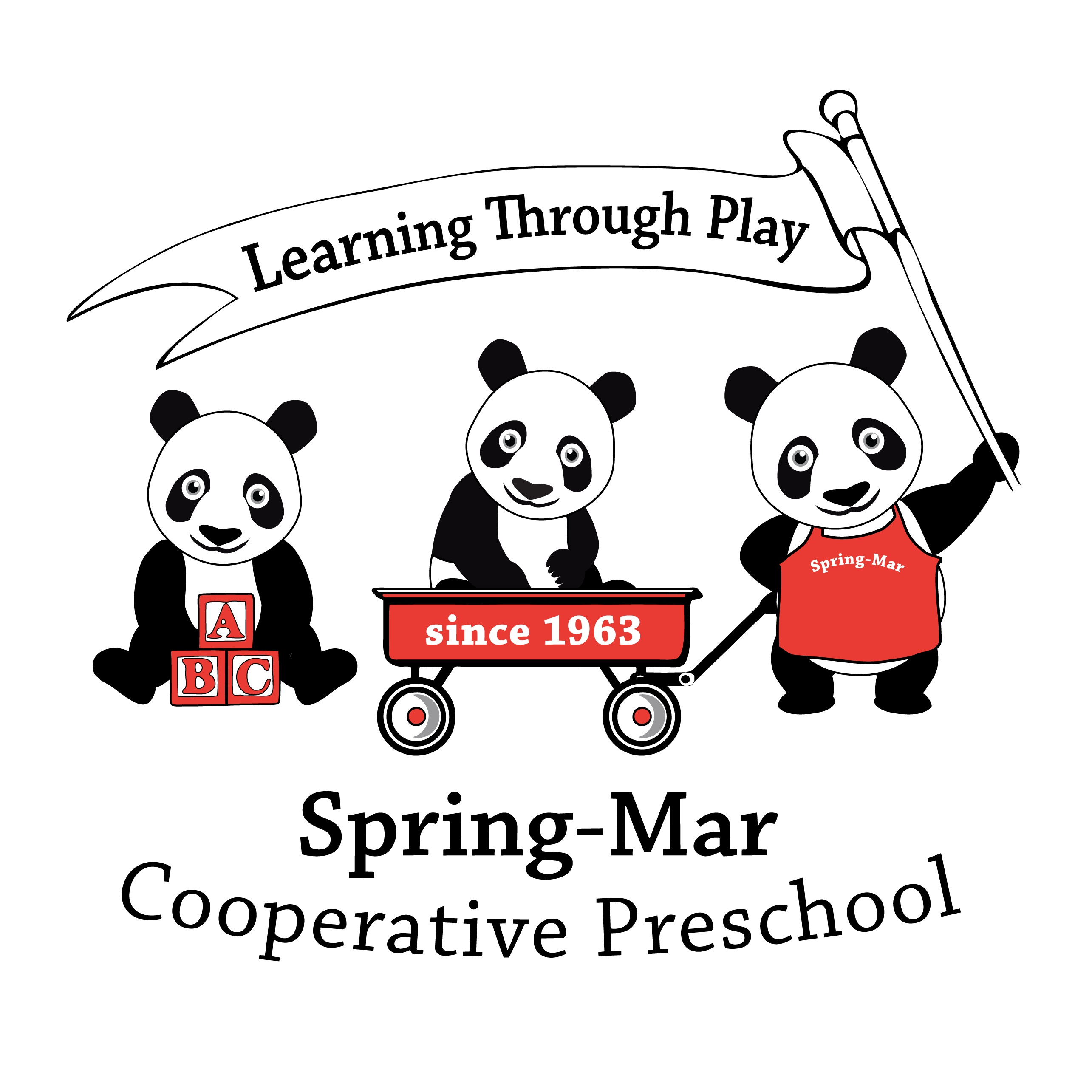
Family Information Form

By providing the information requested on this form, you help us fulfill our mission of serving the growth and developmental needs of each child and family. We regard this form as confidential and as one means of gathering information to insure the safety and well-being of your child. To ensure privacy, we ask you to make a copy of this form and provide an original signature on both copies. (One copy is retained in your child’s file in the locked filing cabinet in the school office and one copy is retained by your child’s teacher in their assessment records.) Please let us know of any changes during the year. Thank you.
Would you be interested in exchanging childcare with another family? Yes No
Would you be interested in providing paid childcare for another family? Yes No
Family Data
Child’s full name_____________________________________________ Nickname___________________________
Sex_________ Age__________ Birthdate________________ Birthplace___________________________
Home address_____________________________________________________________________________________________
Telephone #_________________________ (this is the primary phone we will use for emergencies and phone trees)
Mother’s full name__________________________________________________________________
Home address (if different) _________________________________________________________________________________
Telephone # home____________________ work________________________ cell_________________________
Mother’s Email Address _____________________________________________
Employer Name and Address____________________________________________________________
Occupation__________________________________Hrs/days_________________________________
Father’s full name____________________________________________________________________
Home address (if different) _____________________________________________________________
Telephone # home____________________ work________________________ cell_________________________
Employer Name and Address____________________________________________________________
Occupation__________________________________Hrs/days_________________________________
If mother and father are separated or divorced, please respond to the following:
Date the separation/divorce occurred ___________________________
The custody arrangements are as follows _____________________________________________________________________
Name of persons living in household (siblings, grandparents, nanny, au pair, etc.). Please list sibling ages.
Name Age Name Age
_______________________________________________ __________________________________________________

Names of significant people who care for your child (grandparent, neighbor, nanny, etc.)
Name Relationship to child
__________________________________________________ ______________________________________
__________________________________________________ ______________________________________
__________________________________________________ ______________________________________
If your child is adopted, please indicate any information or circumstances that may be helpful. ____________________________________________________________________________________________________________
____________________________________________________________________________________________________________
Types and names of pets ____________________________________________________________________________________
Religious preference ________________________________________________________________________________________
Has your child had any previous preschool or group experience? If so please indicate the following:
Year Place Teacher or Facilitator
____________ ____________________________________ ____________________________________
____________ ____________________________________ ____________________________________
Please list two people to contact if parents cannot be reached. (Can be family, friends, or neighbors but should be someone who knows the child and lives relatively close.)
Name Address Daytime Phone #
__________________________ __________________________________________ _____________________
__________________________ __________________________________________ _____________________
In addition to the people identified above, list any other people authorized to pick up your child. ____________________________________________________________________________________________________________
____________________________________________________________________________________________________________
Are there any persons NOT authorized to pick up your child? Please list. ____________________________________________________________________________________________________________
Child’s physician:_________________________________________ Phone #: ___________________________
Does your child have any known allergies? If so, please note and describe all allergies (food, medicine, environmental, etc.) and child’s reaction. ____________________________________________________________________________________________________________
____________________________________________________________________________________________________________
Relative to the allergies described above, what precautions and procedures do we need to take? ____________________________________________________________________________________________________________
____________________________________________________________________________________________________________
Does your child have any chronic medical conditions (asthma, diabetes, etc.)? Please describe: ____________________________________________________________________________________________________________
____________________________________________________________________________________________________________

Is your child routinely on medication? Please list medications. IF THESE MEDICATIONS ARE TO BE ADMINISTERED DURING SCHOOL HOURS, THE MEDICATION NEEDS TO BE NEW AND IN ITS ORIGINAL PACKAGING WITH THE PRESCRIPTION ON THE MEDICATION. Please see Director for further assistance. ____________________________________________________________________________________________________________
____________________________________________________________________________________________________________
Please list the names of individuals authorized to have access to your child’s health information. ____________________________________________________________________________________________________________
If your child is in the midst of toilet training, please provide any information that may be useful. ____________________________________________________________________________________________________________
____________________________________________________________________________________________________________
It is a policy of Spring-Mar to retain a record of an IEP/IFSP for every child receiving public or private services (for developmental delays in areas such as speech, language, gross and fine motor, etc.) so that our staff may match and enhance their delivery of educational and support services to your child. Please describe the kind of services and the service provider’s name and agency. ____________________________________________________________________________________________________________
____________________________________________________________________________________________________________
An IEP/IFSP is currently on file: Yes No An IEP/IFSP is forthcoming: Yes No ETA __________
Please note any concerns or observations you would like to share with regard to the physical/fine and gross motor growth and development of your child. ___________________________________________________________________________________________________________
___________________________________________________________________________________________________________
Social and Emotional Information
The following questions relate specifically to growth and development. While growth and development are on an expected continuum, they are also unique and individual to each child. Please respond to the following to reflect your child at present. You are always invited to update this form or notify staff of changes at any time.
My child seems happiest when he/she: ____________________________________________________________________________________________________________
____________________________________________________________________________________________________________
New situations are more comfortable for my child if: ____________________________________________________________________________________________________________
____________________________________________________________________________________________________________
At Spring-Mar, we work to assist children in feeling secure and comfortable in our setting. Young children often have a security or attachment item (blanket, lovey, special stuffed animal, etc.). Please tell us if your child has such an item. ____________________________________________________________________________________________________________
If I were to name something my child were worried about or afraid of it would be: ____________________________________________________________________________________________________________
____________________________________________________________________________________________________________
How do you handle worries or fears? ____________________________________________________________________________________________________________
____________________________________________________________________________________________________________
My child seems frustrated or angry when he/she: ____________________________________________________________________________________________________________
____________________________________________________________________________________________________________
If the need arises at home, how is your child disciplined? ____________________________________________________________________________________________________________
____________________________________________________________________________________________________________
What are important rules in your home? ____________________________________________________________________________________________________________
____________________________________________________________________________________________________________
Please describe any events or situations relating to your child that may be helpful to the teacher (births, deaths, moves or change in family life, etc.).
____________________________________________________________________________________________________________
____________________________________________________________________________________________________________
My child has evidenced a strong dislike or avoidance of: ____________________________________________________________________________________________________________
____________________________________________________________________________________________________________
My child has evidenced a strong liking or attraction to: ____________________________________________________________________________________________________________
____________________________________________________________________________________________________________
Please note any concerns or observations you would like to share with regard to the social and emotional growth and development of your child.___________________________________________________________________________________________________
____________________________________________________________________________________________________________
Cognitive and Language Information
Spring-Mar is a firm adherent to both educational theory and teaching practices that affirm a child’s first and family language as one to be respected and supported. We recognize this as critical when we remember that thinking and language functions are intricately related.
The language(s) spoken in our home is (are): ________________________________________________________________
My child’s primary language is: ____________________________________________________________________________
My child’s second language is: ______________________________________________________________________________
Sometimes children develop their own vocabulary for important things. Please note any designations or substitutions your child has or family phrases that would be helpful to know. ___________________________________________________________________________________________________________
___________________________________________________________________________________________________________
Please note any concerns or observations you would like to share with regard to the speech and language development of your child.
___________________________________________________________________________________________________________
Cultural Information
What are important celebrations or rites of passage in your home? ____________________________________________________________________________________________________________
____________________________________________________________________________________________________________
Please share any relevant non-allergy food issues. ____________________________________________________________________________________________________________
Do you have any cultural concerns or issues we could address?
____________________________________________________________________________________________________________

Parent Expectations
In order to serve you to the best of our ability, the following information would be helpful.
The thing(s) I would most want you to know and learn about my child is (are): ____________________________________________________________________________________________________________
____________________________________________________________________________________________________________
____________________________________________________________________________________________________________
The kind of school experience I would most like to see for my child this year would be:
____________________________________________________________________________________________________________
____________________________________________________________________________________________________________
The areas of growth that I would like to see for my child this year: ____________________________________________________________________________________________________________
____________________________________________________________________________________________________________
I chose Spring-Mar for my child this year because: ____________________________________________________________________________________________________________
____________________________________________________________________________________________________________
If your child is enrolled in our Pre-Kindergarten program, which elementary school will he/she be attending the
following year? ____________________________________________________________________________________________________________

Additional Comments: ____________________________________________________________________________________________________________
____________________________________________________________________________________________________________
____________________________________________________________________________________________________________

Form completed by ___________________________________ Date_____________________________

