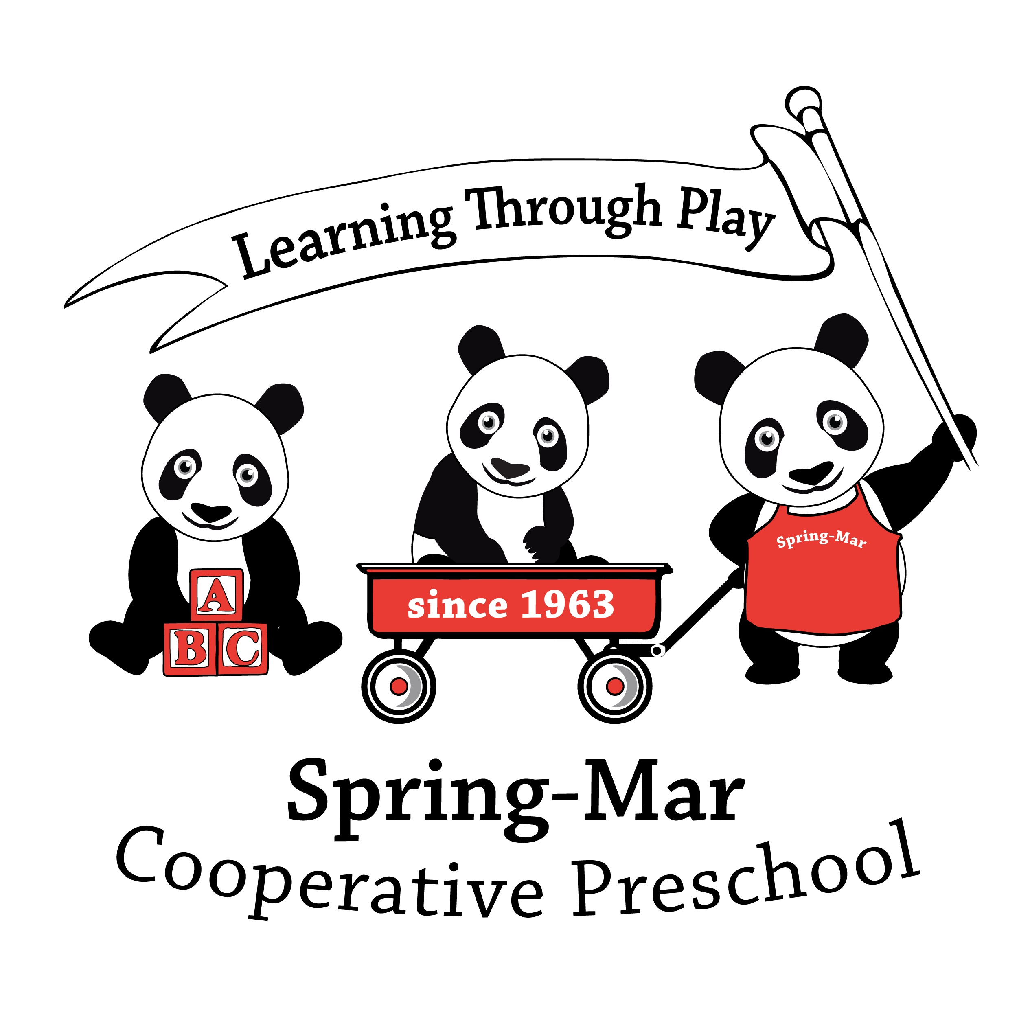
Co-oping Parent Obligations

Welcome to Spring-Mar Cooperative Preschool!
As a co-oping parent (also known as parent helper, or co-oper) at Spring-Mar, you get to enjoy the wonder of a child’s earliest education and experience all THEY experience in the classroom. In order to have a healthy, safe and productive year, each TA must fulfill the following requirements:
- Complete all necessary Background Check and Adult Health forms as listed on the student’s paperwork checklist and submit a $26 check for each co-oping parent by June 1st, 2016. You cannot be added to the co-op schedule until these forms have been returned.
- View the “Suspected Child Abuse and Neglect Video” at the beginning of the child’s tenure at Spring-Mar, complete the accompanying form, and return it by Back to School night in early September. http://www.spring-mar.org/va_mandatory_video
- View the “Spring-Mar Co-Oping Video” each year, complete the accompanying form, and return by Back to School night in early September. http://www.spring-mar.org/sm_video
- Attend Back-to-School night in early September.
- All Parent Helpers must complete four (4) hours of parent education training over the course of the school year per Virginia licensing requirements. Viewing the videos (#2 and #3 above) counts as ½ hour (for each video) and the Back-to-School Night orientation counts for another hour. Additional ways to get parent education hours include: shadowing a returning member on a co-op day, reading books or articles, taking a parenting seminar/webinar/class, taking a CPR class, etc.
- As a co-oping parent, you are responsible for performing all duties required of the co-oping parent that day. Please note the following penalties that may be assessed if obligations are not met:
  - Co-oping Parent No-Show: For failure to show or find a substitute on an assigned Parent Helper day or Chaperoned Field Trip, a $50 fee for use of on-call family if activated prior to 9am and a $100 fee for use of on-call family if activated after 9am on day of co-oping.
  - Co-oping Parent Late Arrival: $15 for a Parent Helper arriving less than 30 minutes before the scheduled start time of the class on his/her co-oping day.
  - Clean-Up: $10 for failure to complete clean-up duties as specified for your class when working as a parent helper.
  - On-Call Co-oping Parent No-Show: $100 fee for failure to show or find a substitute on an assigned On-Call day.
By signing below, you acknowledge what is expected of you as a Co-oping Parent at Spring-Mar. Contact Diane Young at 703-489-3813 or membership.springmar@gmail.com with any questions or concerns.
Please complete a separate form for each co-oping parent.
Co-oping Parent Name (print): ____________________________________
Co-oping Parent Signature: ______________________________________
Co-oping Parent Email Address: ___________________________________
Phone Number: ________________________________________________

